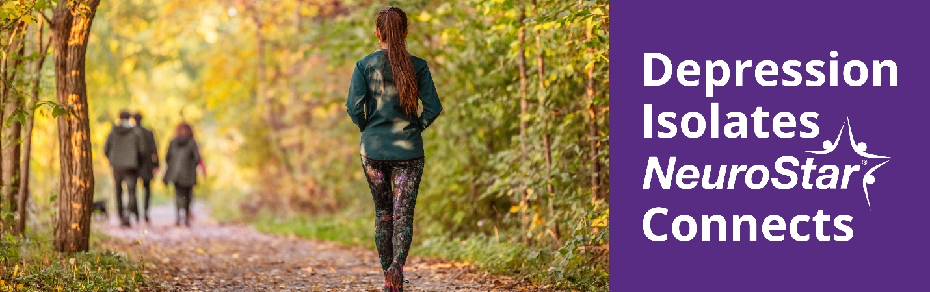
Dear <Patient Name >,

As the days grow shorter and the weather colder,
does it seem like everything becomes just a little bit harder?

When the bright colors from Autumn leaves start to dull and fall from the trees, many of us feel a sense of sadness. It’s no secret that, for some people, Fall and Winter can be very difficult when it comes to managing depression.

While it may seem normal to experience some sadness with the end of Summer, there is no need to suffer all the way through winter.

If you are already taking antidepressants, but it still feels like these symptoms are impacting your quality of life, it may be time to explore NeuroStar TMS, a noninvasive, non-drug treatment for depression.

We offer free consultations on NeuroStar TMS.
To schedule a consult, call < XXX-XXX-XXXX>

Give us a call to discuss your options.

<Practice Name>
<Practice Address / Logo >

____________
The NeuroStar Advanced Therapy System is indicated for the treatment of depressive episodes and for decreasing anxiety symptoms for those who may exhibit comorbid anxiety symptoms in adult patients suffering from Major Depressive Disorder (MDD) and who failed to achieve satisfactory improvement from previous antidepressant medication treatment in the current episode.
The NeuroStar Advanced Therapy system is intended to be used as an adjunct for the treatment of adult patients suffering from Obsessive-Compulsive Disorder (OCD).
The most common side effect is pain or discomfort at or near the treatment site. These events are transient; they occur during the TMS treatment course and do not occur for most patients after the first week of treatment. There is a rare risk of seizure associated with the use of TMS therapy (<0.1% per patient).
Visit neurostar.com for full safety and prescribing information.
53-55144-002 Rev B

