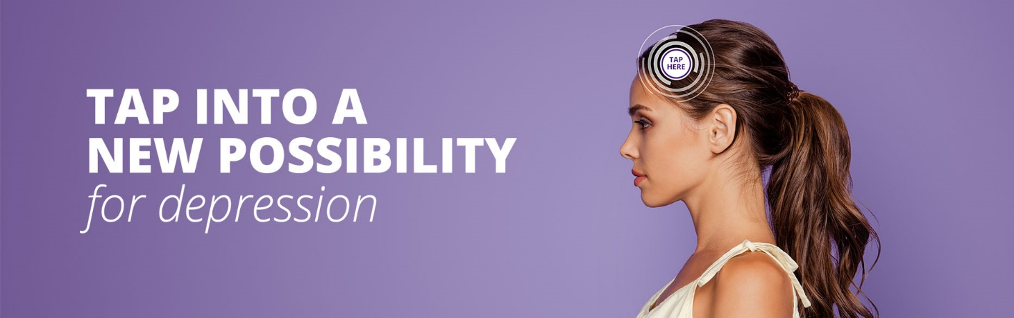
This script is intended to provide your NeuroStar TMS coordinator with all the information they need to record an on-hold phone recording message.

Please contact your Practice Development Manager to request additional information or visit www.neurostar.com

Option 1:
I am < Name here> from < Hospital / Office Name here>.

Do you suffer from major depressive disorder? And have not found relief with antidepressants?

Antidepressants are not the right solution for everyone. And dealing with the side effects of medication can be exhausting and unpleasant for some. But there are other options. TAP INTO A NEW POSSIBILITY FOR DEPRESSION WITH NEUROSTAR.

NEUROSTAR TMS is a proven, FDA cleared, depression relief that lasts – treating depression at the source, without the side effects of medication.

A study of NeuroStar patients who completed treatment showed that 83 percent found measurable relief, and 62 percent experienced complete remission of their depression.
NeuroStar is non invasive.
It’s not a shock therapy.
And it is covered by most insurance.

We offer free consultations to see if NeuroStar TMS is right for you.
Contact me or <Place Name and Title here> in my practice for more information or to schedule a free consultation.

Option 2:
I am < Name here> from < Hospital / Office Name here>.

Do you suffer from major depressive disorder? Have antidepressant medications not helped you? Antidepressants don’t work for everyone. But NeuroStar TMS is proven depression relief that lasts, without the side effects of medication.
It’s non invasive.
It’s not shock therapy.
And it is covered by most insurance.

TAP INTO A NEW POSSIBILITY FOR DEPRESSION WITH NEUROSTAR.

We offer free consultations to see if NeuroStar TMS is right for you.
Contact me or <Place Name and Title here> in my practice for more information or to schedule a free consultation.

Indication
The NeuroStar Advanced Therapy System is indicated for the treatment of depressive episodes and for decreasing anxiety symptoms for those who may exhibit comorbid anxiety symptoms in adult patients suffering from Major Depressive Disorder (MDD) and who failed to achieve satisfactory improvement from previous antidepressant medication treatment in the current episode.

The NeuroStar Advanced Therapy system is intended to be used as an adjunct for the treatment of adult patients suffering from Obsessive-Compulsive Disorder (OCD).
NeuroStar Advanced Therapy is only available by prescription. A doctor can help decide if NeuroStar Advanced Therapy is right for you. Patients’ results may vary.
Important Safety Information
The most common side effect is pain or discomfort at or near the treatment site. These events are transient; they occur during the TMS treatment course and do not occur for most patients after the first week of treatment. There is a rare risk of seizure associated with the use of TMS therapy (<0.1% per patient). Full safety and prescribing information can be found at neurostar.com.
NeuroStar Advanced Therapy should not be used with patients who have non-removable conductive metal in or near the head. NeuroStar Advanced Therapy has not been studied in patients who have not received prior antidepressant treatment.
53-55089-000 Rev B

