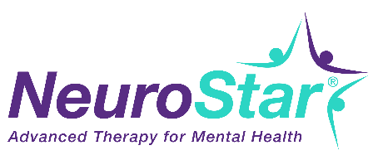

NeuroStar Patient Announcement Email

Subject: Safe, Effective, Non-Drug Depression Treatment Available

(Insert Practice Logo)

As a valued patient, we want to update you on medical advances in our practice. We now offer NeuroStar Advanced Therapy, a proven treatment option for adults who have depression and have not responded to antidepressant therapy.¹

What Is NeuroStar Advanced Therapy?
NeuroStar uses an MRI* strength magnet to stimulate underactive areas of the brain that control depression.²
Treatment with NeuroStar is easy:
- Treatment sessions are done in our office in just under 19 minutes per day for most patients
- Major Depressive Disorder treatment is 36 daily sessions consecutively (Mon-Fri)
- You are awake during treatment and you can return to normal activities right away.
- It’s covered by most health insurance plans, including Medicare and Tricare
Does It Work? Is It Safe?

NeuroStar Advanced Therapy was FDA-cleared in 2008 and is backed by more clinical studies for depression than any other TMS device.³ In a NIMH-funded, independent, randomized controlled trial, patients treated with TMS using the NeuroStar Advanced Therapy System, were 4 times more likely to achieve remission compared to patients receiving sham treatment.⁴

If you or someone you know is suffering from depression, contact our office today to schedule a complimentary consultation (XXX) XXX-XXXX or info@website.com.

Sincerely,

Provider / Office Team

*magnetic resonance imaging

References:

¹Janicak PG, et al. (2008). J Clin Psychiatry, 69(2): 222-232.,
² Post A, et al. (2001). J Psychiatric Research, 35:193-215 6. Liston C, et al.(2014). Biol Psychiatry, 76(7):517-26.
³ Neuronetics Inc data on file
⁴ George, MS et al (2010) Arch Gen Psychiatry, 67(5): 507-­516.

Visit neurostar.com for safety information and indications for use.

